D11 E2E Integration Specification -
GDE14 - ITEMLOCCUST

1. Version, Approval, Distribution and Signoff 3
1.1 Version History 3
1.2 Version Approval 3
1.3 Distribution List 3
1.4 Document Sign-Off 4
1.5 Stakeholder 4
2. Assumptions, Dependencies, Open Actions 5
2.1 Assumptions 5
2.2 Dependencies 5
2.3 Open Actions 5
3. Document Purpose 5
4. Reference Documents 7
5. Glossary 7
6. Data Entity Detail 8
6.1 Functional Description 8
6.2 High level description of data flow 8
7. Data Entity Processing 9
7.1 Source Systems 9
7.1.1 MDM 10
7.2 Inbound Integration - Source to Landing 10
7.3 Data Hub Processing 11
7.3.1 Landing Zone 11
7.4 Outbound Integration - Provision to Target System 11
7.4.1 Provision BY to DMS (Blue Yonder) 11
8. Go Live Considerations 12
9. Unit Test Scenarios 12
9.1 Inbound Integration - Source System to Landing 12
9.2 Outbound Integration - Provisioning to Target system 13
10. Error and Exception Handling 14

Version, Approval, Distribution and Signoff

Version History

Document Control
This document will be owned and maintained by the groups and members listed below. All version management and future changes must involve the owners listed below.
Version | Date Created | Created/ Amended By | Change Detail
V1.0 | 29-Mar-24 | Sesha Venkata Sriram Erramilli | Initial Draft

Version Approval
Version | Date Approved | Approved by | Change Detail

Distribution List
Recipient | Role
Remi Guillon | Project Sponsor
Erik Lenz | Head of Supply Chain Excellence
Steve Dickason | Head of Data Strategy, Governance & Architecture
Jessica Bolte | Project Manager
Hana Fucimanova | Solution Architect
Barbara Lisowska | Head of COE SC Processes
Benjamin Bruhn | Head of Supply Chain Enablement
Pia Lorena Hugo | Manager E2E Supply chain Planning
Jan Eismann | E2E SC Planning Solutions Manager
Marion Weber | Manager E2E Business Processes Master Data
Anne Mareike Borchardt | Manager SC Business Intelligence
Jing Xie | Senior Engineer SC Business Intelligence
Dirk Biehl | Integration Architect
Maciej Grebski | Head of Demand Planning
Lesya Toryanyk | Demand Planning Transformation Manager
Mohamed Khalifa | IT Business Partner
Patrice Gourlet | Head of Data Strategy Governance and Architecture Governance
Javier Romero Blazquez | Head of Data and Integration Global Solution Delivery
Lalit Kapur | Data Lead
Lokesh Ramesh | Integration Lead
Sumanta Dutta | Data Architect
Keshav Mathur | Senior Data Design Consultant
Jairam Mood | Data Functional Consultant
Ramesh Shah | Data Consultant

Document Sign-Off
Where relevant this document has been received and reviewed by the following people. Sign off via email to the solution architect to indicate the document has been reviewed and the proposed solution is acceptable for the sections indicated.

Name | Role
Sumanta Dutta | Data Architect
Lalit Kapur | Data Lead
Lokesh Ramesh | Integration Lead
Javier Romero Blazquez | Head of Data and Integration Global Solution Delivery
Steve Dickason | Head of Data Strategy, Governance & Architecture

Stakeholder
Group / Team / Stakeholder | Focus Area
Technical Design Authority | Help validate the solution’s integrity and to ensure it is aligned to the Imperial Brands architecture principles
Engineering Team | Obtain directions as to the specific capabilities to be implemented using the defined components.  Understand how the various components defined within the solution interact.
Testing Services | Help the team assess the testing scope, producing relevant test cases and test scripts for integration, performance, and user acceptance testing.
Business Stakeholders | Understand how the defined application and platform architecture described in this document deliver their requirements.
Other resources responsible for the architecture function within IB or interested third parties, i.e.  - Integration Architects  - Data Architects  - Enterprise Architects  - System Architects  - Application Architects  - Business Architects | Responsible for ensuring that the end-to-end solution addresses the functional and non-functional requirements and is feasible given the constraints under which the solution will have to operate.

Assumptions, Dependencies, Open Actions

Assumptions
- There is currently no existing interface that can be used to source ITEMLOCCUST data. A custom query will be created to source the data from MDM.
Query name: V_MDM_GDE14_ITEMLOCCUST
- This document is created from the DP perspective.
- SCD2 is not required as only key columns, i.e., ITEM_CODE & Location are coming from the MDM.

Dependencies
NA

Open Actions

NA

Document Purpose
The purpose of this document is to describe how ITEMLOCCUST entity data:
- gets extracted from the source system (MDM) into the Datahub landing zone.
- sent to the target system (Blueyonder) from the Datahub provision zone.

The current version of this document created in March 2024 just covers legacy data sources.

The purpose of the Data Lake Zones is to establish a structured and efficient data management framework that facilitates seamless data ingestion, processing, and storage. Each zone serves a distinct purpose and caters to the various stages of data lifecycle within Data Hub. The Data Lake Zones is to establish a scalable, flexible, and governed data architecture that ensures the seamless flow of data from its raw form to Model.

The document is intended to:
- Acknowledge, but not restate the Imperial Brands requirements.
- Align requirements to the solution via a conceptual architecture.
- Define the interface for each layer data flows through.
- Serve as a guide and align to the resulting blueprint for technical implementation.

This document describes the source and target integration implementation for the ITEMLOCCUST entity. The design pattern for the source and target integrations are documented in detail inside D19 documents. ADF connectors are predominantly used for these integrations.

The Data Lake comprises five distinct data zones – Landing, Bronze, Silver, Gold and Provision. The subsequent sections define the approach for extracting the ITEMLOCCUST data from the MDM source and post processing of data (after processing through aforementioned data layers), how data is being sent to target systems like Noodle and Blueyonder from Provision area.

It covers each of the steps required to load, transform, and store this data as it passes through each of the layers of the Data Hub, as shown below. The design of the Data Hub is defined in D01 Data Hub Solution Design Document.

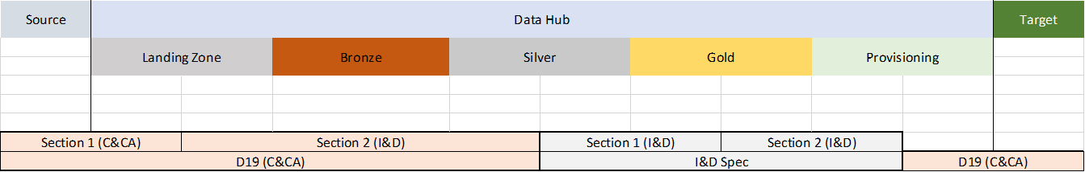

Reference Documents
Ref. | Filename & Link
 | A02 E2E GSC Data Model Requirement
 | A05 Data Solution Architecture
 | D01 Data Hub Solution Design Document
 | D05 Data Hub Data Mapping specification
 | D09 BY Data Quality Report
 | D20 MX Framework Documents
 | D19_IB-IntTechSpec_Pattern_Common
 | KDD-01 GSC Data Hub Standards

Glossary

Acronym | Description
ADB | Azure Databricks
ADF | Azure Data Factory
ADLS | Azure Data Lake Storage
API | Application Programming Interface
APO | SAP Advanced Planner and Optimizer
BOM | Bill of Material
BY | Blue Yonder. An intelligent supply chain platform
CSV | Comma-Separated Values
CDC | Change Data Capture
DH | Data Hub
DMS | Data Management System
E2E | End-To-End
EDM | Enterprise Data Model
ERP | Enterprise Resource Planning
GSC | Global Supply Chain
SCP | Supply Chain Planning
SCPO | Supply Chain Planning and Optimization
SOAP | Simple Object Access Protocol
XML | Extensible Markup Language

Data Entity Detail

Functional Description
This technical & functional specification document focuses on describing the "ITEMLOCCUST" entity.

ITEMLOCCUST defines combinations of entity references to ITEM, LOCATION and Customer.

Item Location Customer entity is used to handle data related to a location that can represent a supplier, vendor, plant, distribution center, warehouse, store, a virtual location, or other similar location. Over ITEMLOCCUST, Location related to the items that are distributed to Local Customer.
.

High level description of data flow
This section describes BY end-to-end daily ITEMLOCCUST data flow at high level. In depth technical details are given in the subsequent sections.
- ITEMLOCCUST data is sourced from MDM using SQL queries.
- Data Hub reads this ITEMLOCCUST data using Azure Data Factory (ADF) pipeline.
- The data will be written to the Data Hub landing Zone in the CSV format.
- The file structure is validated in the landing zone. This ensures that input data file is in the specified format (i.e.name, number, and order of columns in the file are not changed.)
- If any file fails structure validation, then it is moved to the Error sub-folder in the Landing zone.
- Valid CSV files in the Landing zone will be processed into the Bronze zone and stored as delta table format. This process appends data in the Bronze zone.
- ADF moves successfully processed file in Data Hub from the Landing zone to its Archive sub-folder.
- Between the Bronze zone and Silver zones the data quality checks are performed, and invalid data is written to the error table in Bronze zone in delta table format along with errors for support team to investigate.
- Data is converted to the target data types after data quality checks are performed and then written to the Silver zone.
- data_source_id, created_date, and modified_date will be added to ITEMLOCCUST Table in the Silver zone. The data source ids are stored in a meta data table (Data Source Table).
- From the Silver to Gold layer, Data is transformed into the Enterprise Data Model target schema.
  - Any errors in the Silver zone will be written to the Silver zone error delta table.
- From the Gold to provisioning, the data is transformed to the schema and structure required by the target in CSV files.
- ADF picks the CSV files from the Provisioning area and copies these to the SFTP server for Blue Yonder.
- ADF moves successfully processed files from the Provisioning layer to its Archive sub-folder.

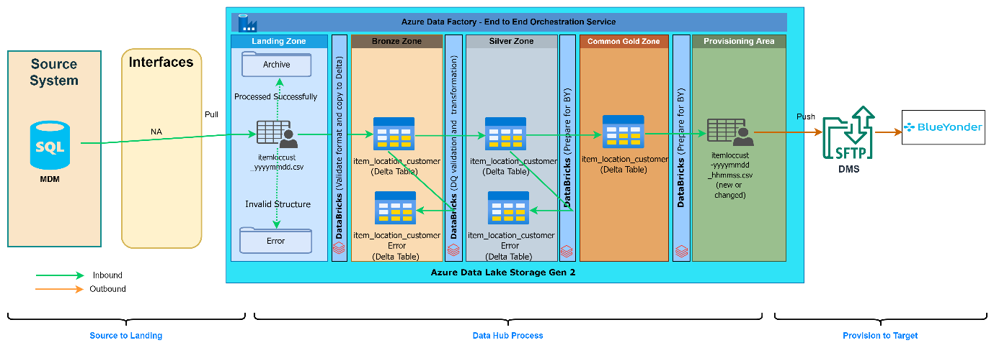
Fig. High level ITEMLOCCUST data processing

Data Entity Processing
The process involves the extraction of data from the source system to the Data Hub on a regular basis. The extracted data is then transmitted to the Data Hub for further processing. After Data Hub completes the necessary processing and transformation of the data into the required format for Blue Yonder, ADF retrieves the processed files and transfers them to an SFTP location. Blue Yonder subsequently pulls the data from the SFTP server at predetermined intervals. This design ensures a seamless flow of data from source systems into Blue Yonder.

The data remains in its native state apart from applying DQ checks up to the Silver layer. Then data is then transformed to the enterprise data model from the Silver to Gold zone.
.

Source Systems
The table below illustrates all the currently known source systems that have been identified for this entity, so far. This has been produced in consultations (latest held on 18 October 2023) with Imperial Brand’s stakeholders. However, as the data fields level mapping exercise for this entity is still ongoing the source systems may change, and the table will be revised accordingly.

Functional Domain(s) | Source System(s) | D19 Patterns | Notes
DP | MDM | MDM to Data Hub | See section 7.1
S4 | S/4HAHA | S4 to Data Hub | -
(ALL) | Data Hub | Data Hub to Blue Yonder | -

The design pattern consists of an Azure Data Factory data pipeline, with linked services for Blue Yonder File Server and Landing Zone connectivity.

The integration pattern in the specification follows the principles of Extract, Load, and Transform (ELT) implemented with Azure Data Factory and AZURE MX.

For inbound integration, records in the following meta data tables will be either updated or inserted.
- SourceMetaData
- SourceTargetMapping
- SourceObjectMetatadata
- mx_trf_execution_details
- mx_trf_function
- orchestration_metadata

MDM
The source system for ITEMLOCCUST entity is MDM.
IB manages its master data in the Kalido MDM system connected with SQL Server as its backend.

Entity-specific details:
- Source system: MDM
- Server: BIPZ84SRDB11
- Database: V_MDM_CORP
- Object Name: <<TBD>>
- Inbound frequency: Daily increment data
- Schedule: Please refer to the D01 Data Hub Solution Design Document, section: Pipeline Run Schedules

Data Hub layers and processing of ITEMLOCCUST data received from MDM is described in the following sections.

Inbound Integration - Source to Landing
MDM to Data Hub - Integration Pattern (DP only)
The Inbound integration from source MDM to Data Hub will follow the pattern described in D19_IB-IntTechSpec_Pattern_MDM_To_Datahub.docx where the data is pulled from MDM database and placed in landing zone, in a “.csv” file format for further processing by Data Hub.

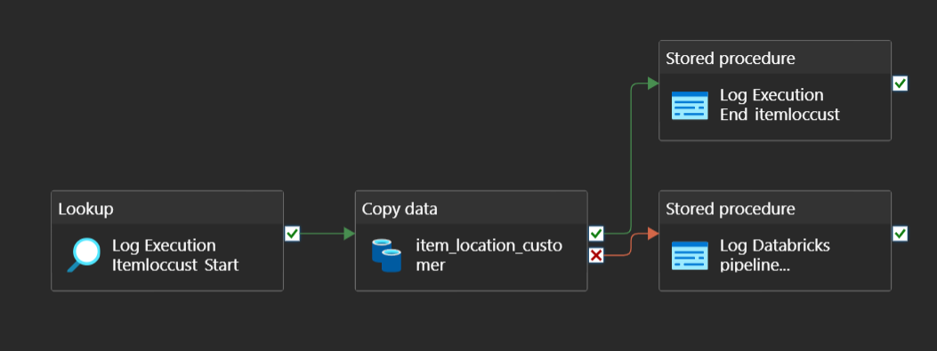
Fig. ITEMLOCCUST Data ingestion pipeline

SAP S/4HANA to Data Hub - Integration Pattern
The inbound integration from SAP S4 to Data Hub will adhere to the pattern outlined in the document D19_IB-IntTechSpec_Pattern_SAP_S4_To_DataHub involving data being pulled from SAP S4 database and placed in landing zone, in a “.csv” file format for further processing by Data Hub.

Data Hub Processing
The Data Hub solution has been built using an accelerator called MX Azure. This enables the user to create new data pipelines by entering data into some orchestration metadata tables that dynamically create new data pipelines.

The parameter table data_load_param will be used to select unprocessed records from the Bronze, Silver and Gold zones those fall within the start_date and end_date range. The start_date will be updated to current system date and time after each successful run.

data_load_param table entries:
dataset | Start_date | End_date | target
ItemLocCust_Bronze_To_Silver | <last successful load date_time> | 31/12/9999 00:00:00 | DH
ItemLocCust_Silver_To_Gold | <last successful load date_time> | 31/12/9999 00:00:00 | DH
ItemLocCust_Gold_To_Provision | <last successful load date_time> | 31/12/9999 00:00:00 | BlueYonder

Landing Zone
- Landing Zone entries:

- Input folder path: landing-zone/mdm/master_data/item_location_customer/data/
- File Name: itemloccust_*.csv.
- Archive Folder Path: landing-zone/mdm/master_data/item_location_customer/archive/YYYY/MM/DD/
- Error Folder Path: landing-zone/mdm/master_data/item_location_customer/error/YYYY/MM/DD/
- Under process file path: NA
- MX Table SourceObjectMetadata entries:
- file_header: ITEM_CODE | location_code
(Columns mapped to source in D05 GDE14 ITEMLOCCUST)
- tgt_file_path: landing-zone/mdm/master_data/item_location_customer/data/

Outbound Integration - Provision to Target System
This section pushes out CSV data files that are generated from the Gold zone based on specifications provided by the target systems.

Provision BY to DMS (Blue Yonder)
Please refer to the below pattern document: Data Hub to Blue Yonder D19_IB-IntTechSpec_Pattern_Datahub_To_BlueYonder v1.0.docx.

The Outbound Integration from Data Hub to Blue Yonder will follow the common pattern described in the above patterns document and the diagrammatic representation is given below where in the ITEMLOCCUST data is pulled from provisioning zone and placed in Blue Yonder SFTP location for further processing by Blue Yonder DMS Integrations.

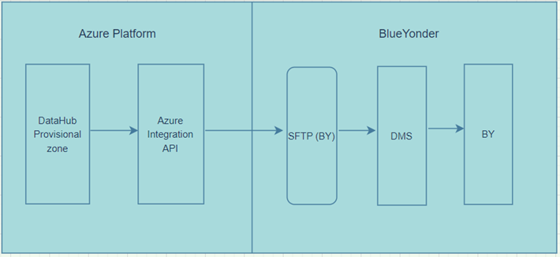

For outbound integration records in the following meta data tables will be either updated or inserted:
- SourceMetaData
- SourceTargetMapping
- SourceObjectMetatadata
- mx_trf_execution_details
- mx_trf_function
- orchestration_metadata

Entity-specific details:
- Outbound frequency: daily
- Schedule: <<TBC>>
- BY SFTP Path: /inbox

Go Live Considerations
NA

Unit Test Scenarios
The goal of unit test scenarios is to confirm the accuracy and reliability of the smallest building blocks of DH processing, allowing for early detection of issues and providing a solid foundation for ensuring the overall quality and robustness.

Inbound Integration - Source System to Landing
See common pattern

Test Case Id | Test Case Type | Test Case Description | Expected Result | Comments
 | Functionality | Pipeline is triggered at scheduled time; it has copied data from source (MDM Query) to target (DH Landing zone) location. Query name V_MDM_GDE14_ITEMLOCCUST | - File is created in target location.  - Pipeline finished with success log.
 | Connectivity | Pipeline is triggered at scheduled time; Failed connecting Source system error received after 3 retries. | - Pipeline finished with Error log.  - Notification sent to Ops team.
 | Connectivity | The pipeline is triggered at a scheduled time and failed to connect to the DH Landing zone folder. System error received after 3 retries. | - Pipeline finished with Error log.  - Notification sent to Ops team.
 | Technical Error | Pipeline copied files from source to target location, however, pipeline ended without getting copy activity’s success response, due to technical error. | - Source files are copied to the target designated location.  - Pipeline finished with Error log.  - Notification sent to Ops team.

Outbound Integration - Provisioning to Target system

Test Case Id | Test Case Type | Test Case Description | Expected Result | Comments
 | Functionality | Pipeline is triggered at scheduled time; it has copied files from source(provision-zone/blueyonder/master_data/export/item_location_customer/daily/yyyymmdd to target(/inbox on SFTP for DMS) location and move activity successfully copied files to archive folder(provision-zone/blueyonder/master_data/archive/item_location_customer/daily/yyyymmdd/) happens successfully in the source system. | - Source files are moved to archive location.  - Source files are moved to the target designated location.  - Pipeline finished with success log.
 | Connectivity | Pipeline is triggered at scheduled time; Failed connecting Source system error received after 3 retries. | - Pipeline finished with Error log.  - Notification sent to Ops team.
 | Connectivity | Pipeline is triggered at scheduled time; Failed connecting Target system error received after 3 retries. | - Pipeline finished with Error log.  - Notification sent to Ops team.
 | Functionality | Target folder(/inbox) in SFTP for DMS location not found. | - Source files are expected to remain in the Source folder.  (provision-zone/blueyonder/master_data/export/item_location_customer/ daily /yyyymmdd/).  - Pipeline finished with error log.  - Notification sent to Ops team.
 | Technical Error | Pipeline copied files from source(provision-zone/blueyonder/master_data/export/item_location_customer/ daily/yyyymmdd/) to target location(/inbox), however, pipeline ended without getting copy activity’s success response, due to technical error. | - Source files are expected to remain in the Source folder, not in Archive folder.  - Source files are copied to the target designated location.  - Pipeline finished with Error log.  - Notification sent to Ops team.
 | Technical Error | Pipeline copied file(s) from source(provision-zone/blueyonder/master_data/export/item_location_customer/ daily/yyyymmdd/) to target location(/inbox), pipeline receives copy activity success response. However, moving successfully copied file(s) activity to Archive folder(provision-zone/blueyonder/master_data/archive/item_location_customer/daily/yyyymmdd/) failed due to technical error. | - Source files are expected to remain in the Source folder, not in Archive folder.  - Source files are copied to the target designated location.  - Pipeline finished with Error log.  - Notification sent to Ops team.
 | Technical Error | Pipeline copied file(s) from source(provision-zone/blueyonder/master_data/export/item_location_customer/daily/yyyymmdd/) to target location(/inbox), pipeline receives copy activity success response. move activity for successfully copied files to archive location folder(provision-zone/blueyonder/master_data/archive/item_location_customer/daily/yyyymmdd/) happens successfully in the source system. However, the pipeline ended without getting move activity’s success response, due to technical error. | - Source files are moved to archive location.  - Source files are moved to the target designated location.  - Pipeline finished with Error log.  - Notification sent to Ops team.

Error and Exception Handling
Error handling, restart ability, and email notification are implemented in generic ADF pipelines and Azure MX, and a detailed description is added in the D01 Data Hub Solution Design Document and D19_IB-IntTechSpec_Pattern_Common.

